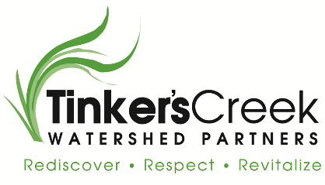
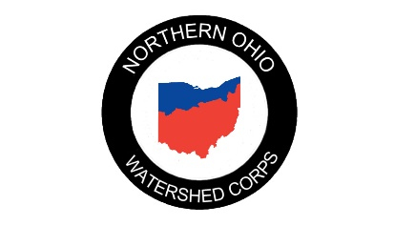
Tinker’s Creek Watershed Partners
The Northern Ohio Watershed Corps
Job Description – NOWCorps Program Director

Tinker’s Creek Watershed Partners (TCWP) is a non-profit, 501(c)(3) watershed organization officially established in 2006. Our mission is to protect and restore water quality and habitats of the Tinker’s Creek and Brandywine Creek watersheds through community partnerships.
Together with our partners, Tinker’s Creek Watershed Partners recognizes the importance of maintaining water quality throughout Northern Ohio. We also believe in educating the public and regional leaders to support behavioral changes that positively affect our water resources. The Northern Ohio Watershed Corps works with watershed groups, soil and water conservation districts, and other conservation nonprofits to facilitate outreach, education, capacity building, environmental stewardship, and stormwater management.

REPORTS TO: Executive Director
SUPERVISES: NOWCorps Member Coordinator
KEY ORGANIZATIONAL RELATIONSHIPS:
- ServeOhio staff
- Host Site Supervisors

STARTING SALARY: $42,000
BENEFITS SUMMARY:
Full-time staff members have available benefits that include health insurance, short-term disability insurance, paid holidays, mileage reimbursement, cell phone stipend, and retirement matching after one year of employment.
POSITION SUMMARY:
This full-time position (40 hours per week) will provide NOWCorps program monitoring, coordinate recruitment, and training services, and assist with the technical aspects, evaluation, and program development for the Northern Ohio Watershed Corps. This position focuses primarily on the policy, procedure, and compliance of the program. The Director will be a member of the Tinker’s Creek Watershed Partners staff and will report to their Twinsburg office. This position is contingent on grant funding and requires a 90/10 split between the NOWCorps Program and TCWP funded tasks.

ESSENTIAL DUTIES AND RESPONSIBILITIES:
90% of time will be spent on the NOWCorps Program:
- Maintain NOWCorps Member records including background checks, eligibility, documentation of hours of service provided, and oversee NOWCorps Members’ compliance.
- Work with Host Site Supervisors to develop appropriate placements for NOWCorps Members. Conduct evaluation with Host Sites Supervisors regarding current members and service projects.
- Assist Member Coordinator with program planning meetings and training activities.
- Monitor program sites to ensure that project requirements and objectives are met on a timely basis. Assist sites in developing program objectives and evaluation tools.
- Serve as principal liaison to ServeOhio staff for day-to-day program implementation issues.
- Coordinate evaluation activities. Assist with the design and development of special studies to investigate unique aspects of the program.
- Compile, edit, and write qualitative and quantitative reports from NOWCorps host sites progress reports and annual renewal application to ServeOhio. Write aggregate sections of reports and analyze statewide impacts.
- Conduct site visits to provide technical assistance to Host Sites. Evaluate member experience and meet with Host Site Supervisors and relevant program staff to review records systems for adequacy to support member, program, and financial data.
- Oversee online reporting. Set up authorized users, monitor data entry, provide technical assistance to program sites as needed and approve program data.
- Assist with the development, execution and collection of sub-recipient Contracts (Memoranda of Understanding) between TCWP and the NOWCorps Host Sites; assure timely submittal of cost reimbursement and financial status reports.
- Assist Member Coordinator with NOWCorps orientation, training, and other professional development opportunities.
- Attended state/national conferences and program director meetings as required.
- Provide trainings to TCWP staff and Host Site Supervisors.

10% of time will be spent on TCWP duties:
• Conduct other duties as assigned to fulfill TCWP’s mission.
• Write and submit grant application to ServeOhio to ensure the continuation of the program

MINIMUM REQUIREMENTS:
• Bachelor’s degree in nonprofit management, environmental science, or related degrees preferred and/or three years professional experience in environmental management, human services, community service, or related field
• Grant writing experience and/or development and fundraising experience
• Experience managing federal and/or state grants preferred
• Excellent verbal communication and interpersonal skills
• Strong writing, research, and analytical/problem-solving skills
• Demonstrated ability to produce high-quality final products
• Knowledge of local environmental issues desirable
• Proficiency in Microsoft Suite, and utilizing the Internet and social media
• Experience with Adobe Suite and WordPress preferred
• Ability to organize and coordinate various activities efficiently and with little supervision
• High degree of independence, flexibility, initiative, and commitment to the program
• Ability to deal effectively with a variety of people and work in a team environment
• Ability to pass a federal background check

PHYSICAL REQUIREMENTS AND WORK ENVIRONMENT
The physical requirements and work environment described here are representative of those that must be met by an employee to successfully perform the essential functions of this job. Reasonable accommodations may be made to enable individuals with disabilities to perform the essential functions. This position requires the following:
• Manual dexterity sufficient to operate telephones, computers, and other office equipment
• Physical ability to kneel, bend, and perform light lifting
• Ability to write and speak clearly using the English language to convey information and be able to hear at normal speaking levels both in person and over the telephone
• Specific vision abilities required by this job include close vision, depth perception, and the ability to adjust focus
Generally, the working conditions are good with little or no exposure to extremes in health, safety hazards, and/or hazardous materials. Though work is normally performed in an office setting, this person must have the ability to travel as required to work with staff, Host Sites, and NOWCorps Members, meet with partners/stakeholders and participate in conferences and outdoor activities such as but not limited to site visits, volunteer activities and project meetings.
Pursuant to applicable federal and state law, any decisions regarding recruitment, employment, placement, compensation, benefits, training, transfer, promotion, and dismissal of personnel will be made without regard to race, creed, color, religion, age, sex, gender identity, marital status, citizenship, handicap, or national origin of the individual.

