Waterfall Tour: Don't Go Chasing Waterfalls
By: Kipp Dietrich
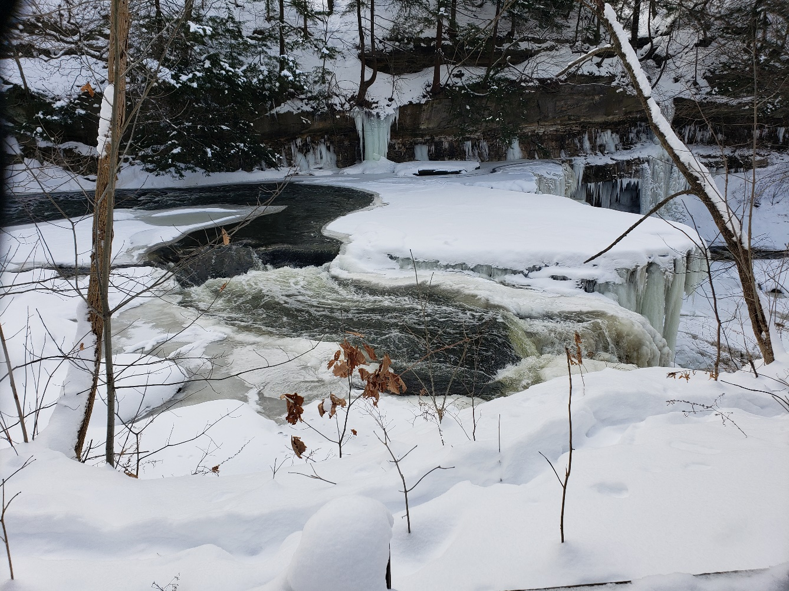

Introduction
Northern Ohio is home to some of the most unique and spectacular waterfalls. Waterfalls are abundant in the area, so it’s not hard to stumble upon some lesser-known ones when you’re hiking through the woods. In this article, we will touch on some of the most awe-inspiring waterfalls that the Tinker’s Creek and Brandywine Creek watersheds have to offer. So, sit back and enjoy some winter scenes, as we set out on our grand adventure to the waterfalls of Tinker’s Creek and Brandywine Creek.
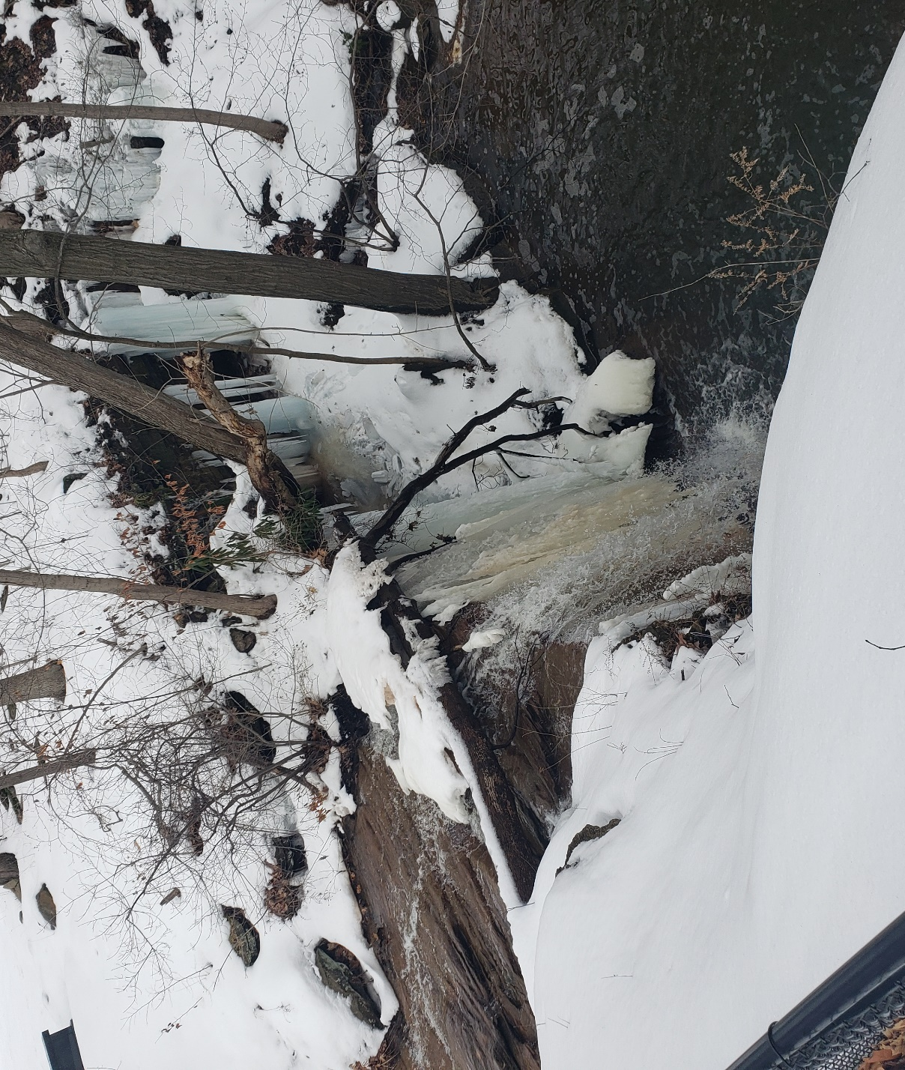
Crown Hill Waterfall

Crown Hill Waterfall is located at the Crown Hill Cemetery in Twinsburg, Ohio. This waterfall is hidden in the back of the cemetery with a small enclave just behind the falls. In winter, this waterfall has many large icicles despite the water still flowing into the small pool/stream below. This waterfall is truly a hidden gem in a somber sanctuary.

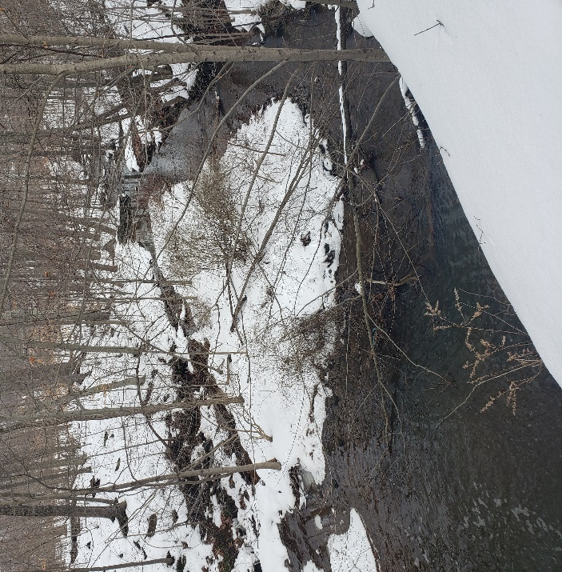

Brandywine Falls
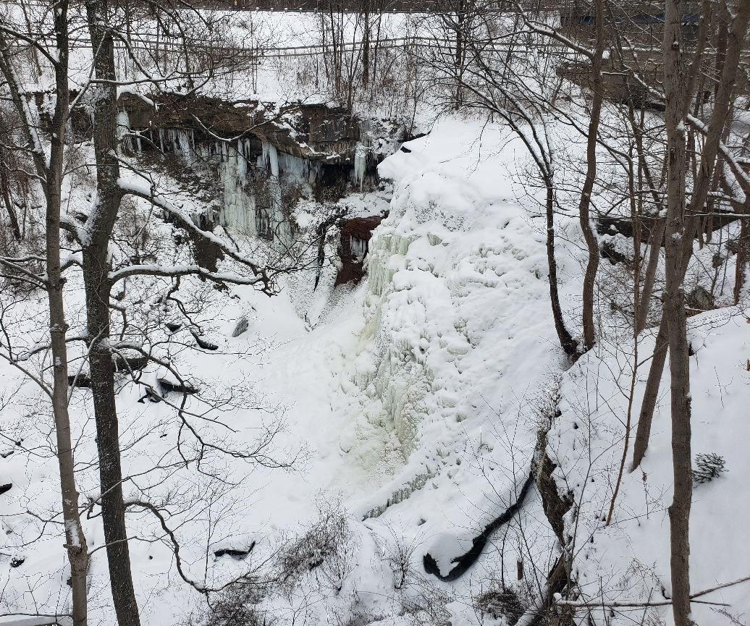
Brandywine Falls flows 86 feet into the valley below. This waterfall is almost completely frozen in the winter, with one small hole allowing water to spray from the frozen wall of ice. While some of the trails are closed in winter, this waterfall is a must-see. Another advantage of visiting in winter is that you can avoid the crowds while you gaze at the winter scene before you.

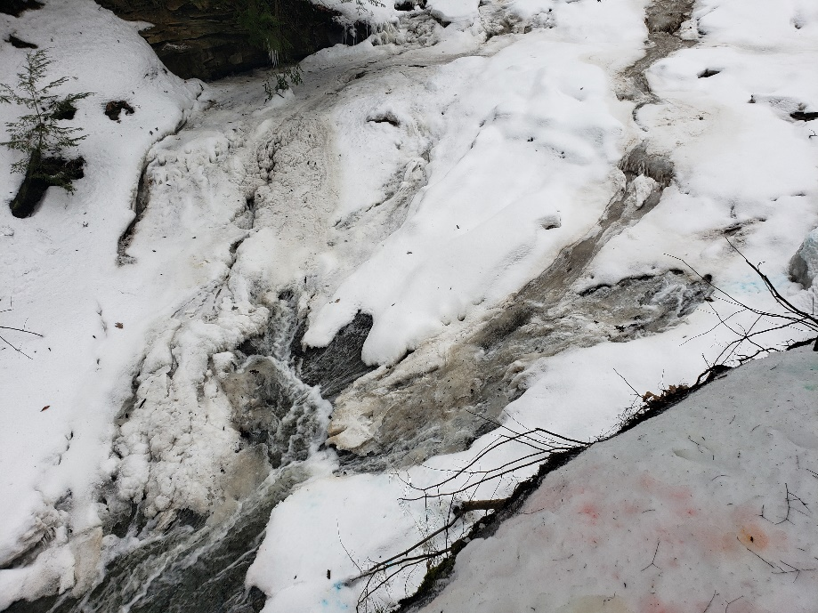
Bridal Veil Falls
Bridal Veil Falls is normally a wide, yet slow flow. Water cascades over the large rocks below, covering them in a veil of water, hence the name. While this waterfall is a beauty to behold in all seasons, winter at Bridal Veil Falls is slow and quiet like the fantastic hike on the snow-covered trails.

Great Falls of Tinker’s Creek
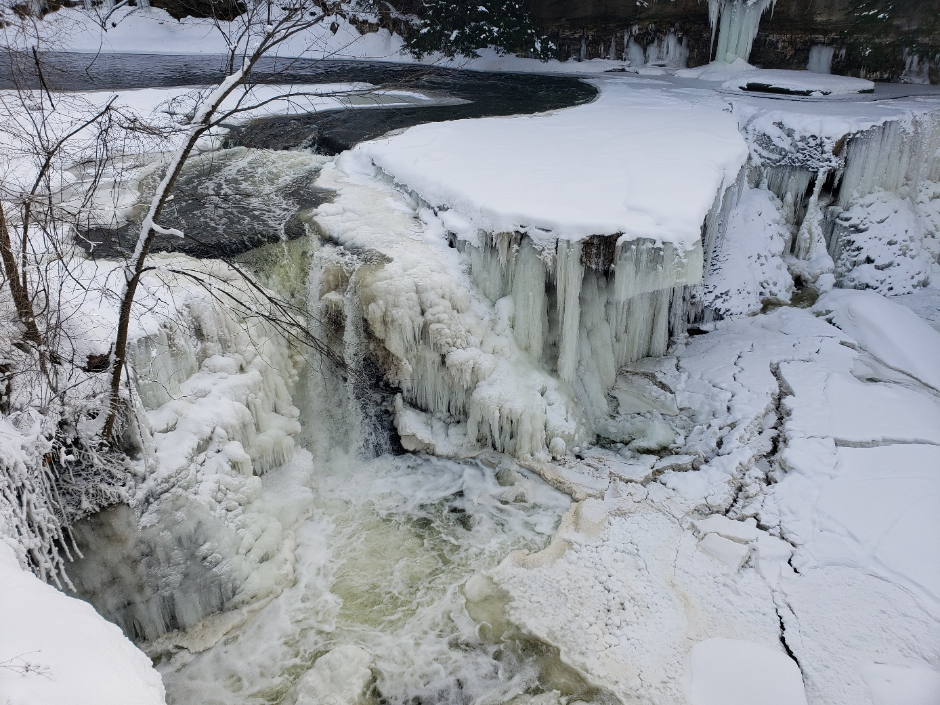

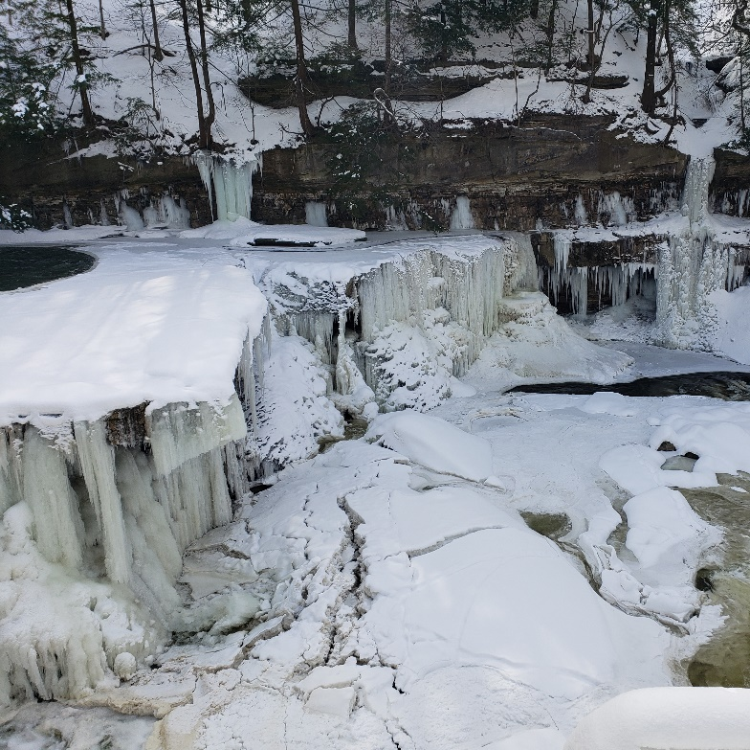
This waterfall has got to be at the top of anyone’s list for the most beautiful frozen waterfall in northern Ohio. The Great Falls of Tinker’s Creek was almost completely frozen in January, with large icicles coating the falls and the cliffs above. When the sun peaks through the clouds and shines on this ice, you may never want to leave the majestic view.

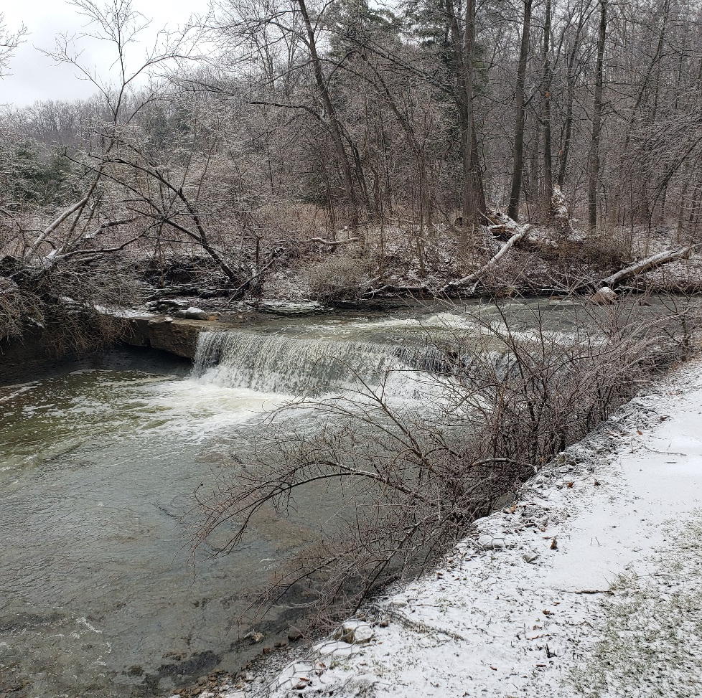
Hemlock Creek “Waterfall”
This “waterfall” is more of a man-made feature. It is beautiful either way, especially in winter. I visited this “waterfall” after a major ice storm, so everything (I mean everything) was coated in a layer of ice. The grass, the rocks, the trees, and even the ice, had a fairly thick coating, which made getting close to the falls without falling in a bit of a challenge. After a painstakingly long and careful scramble, I was rewarded with a magnificent scene as the water crashed into the stream below.

Stone Quarry Falls
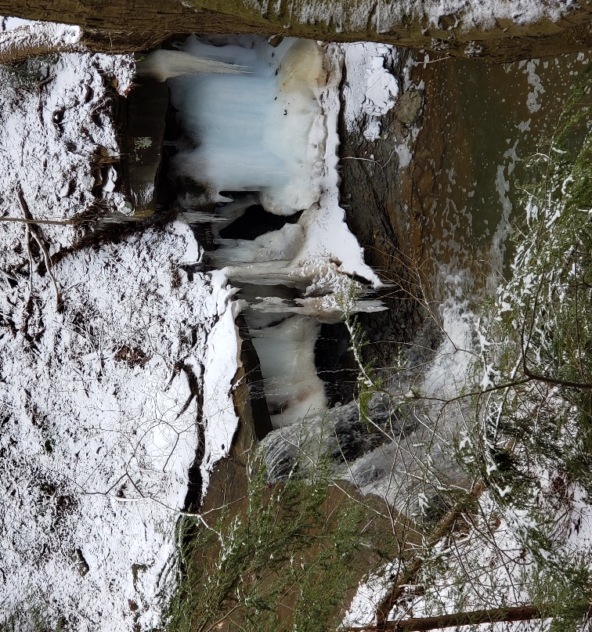
Stone quarry falls is one of the many beautiful waterfalls in the Bedford Reservation. This waterfall can be found along the Bridle trail between Bridal Veil Falls and the Lost Meadows Picnic Area. Deep down in the gorge, this waterfall flows at fast speeds, creating a pleasant roar that can be heard from the trail above. The winter cold forms truly awesome icicles along the valley walls. This waterfall is certainly worth the hike. Just watch your step.

Cascade Park Waterfall
Cascade Park in Hudson, Ohio, has a scenic 1-mile trail. Keep your eyes peeled for the small signs along the path that have information about the different types of trees in the area. If you are looking for more than just a hike, this park also features some clever body-weight exercise machines. through the woods.

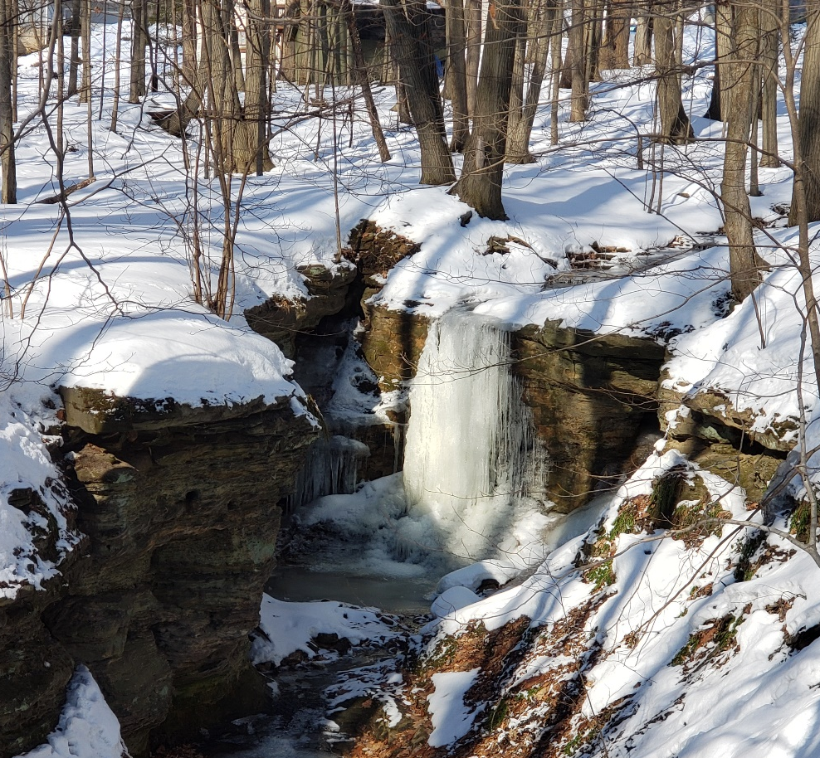
If you can drag your attention away from all these neat features, you’ll notice not one, but two waterfalls that are just a hop, skip, and a jump away from the main trail. The first waterfall (the more impressive of the two), is located about an eighth of the way along the trail. If you go off to the left of the trail, you’ll find a gully with a frozen stream of water flowing from the apex. Continuing along the trail you’ll come across the second waterfall just as you’re nearing the end of the route.

