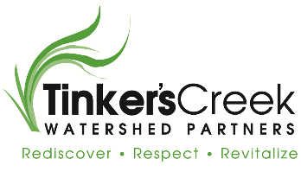
Contact Kate Chapel
Telephone 330-963-6243
Email kchapel@tinkerscreekwatershed.org
Website www.tinkerscreek.org
FOR IMMEDIATE RELEASE
March 19, 2018

FUNDS AWARDED TO RESTORE NATURAL FLOW TO 3,100 LINEAR FT. OF STREAM
TINKER’S CREEK WATERSHED

TCWP will work with Summit Metro Parks & EnviroScience to restore part of Tinker’s Creek

Hudson, OH, March 19, 2018 - Tinker’s Creek Watershed Partners (TCWP) has been awarded a $191,500 Great Lakes Restoration grant from the Ohio Environmental Protection Agency and the United States Environmental Protection Agency. Funds will be used to restore instream habitat to a historically channelized portion of Tinker’s Creek, plant native species along its banks, remove invasive species, and restore natural flow.

Tinker’s Creek Watershed is comprised of 24 communities, drains 96.4 square miles of land, and is approximately 30 miles long. It is the largest tributary to the Cuyahoga River.
The creek is impaired by sedimentation, organic enhancement, low in-stream dissolved oxygen, nutrient enrichment, toxicity, habitat alteration, as well as yet to be determined impairments. Habitat impairments reflect a historically dredged stream in various stages of recovery.

Tinker’s Creek Watershed Coordinator, Kate Chapel, explains: “This funding will increase our progress towards restoring habitats and water quality in the watershed. This site is close to meeting water quality standards, and with a little help we believe it will reach those standards. We are excited about the opportunity to put this project on the ground with great partners in the Ohio EPA, Summit Metro Parks, and EnviroScience.”

Tinker’s Creek Watershed Partners is a non-profit 501(c)(3) watershed organization officially established in 2006. Our mission is to protect and restore water quality and habitat of the Tinker’s Creek watershed through community partnerships.

# # #

If you would like more information about this project, contact Kate Chapel at 330-963-6243 or kchapel@tinkerscreekwatershed.org.

